Building SAPUI5 Hybrid Application & Consuming SAP NetWeaver Gateway OData Service

Author: Yaohua LIANG ([yaohua.liang@capgemini.com](mailto:yaohua.liang@capgemini.com))

Created on 17/04/2014, updated on 23/04/2014

## Chapter 1: Set up the development environment

Before getting start building, you need to have the right ‘equipements’!

There’re already a lot of tutorials that you can find on Google, for example:

*[1]* [*http://scn.sap.com/community/developer-center/front-end/blog/2013/06/01/how-to-install-a-basic-development-environment-for-sapui5*](http://scn.sap.com/community/developer-center/front-end/blog/2013/06/01/how-to-install-a-basic-development-environment-for-sapui5)

*[2]* [*http://scn.sap.com/docs/DOC-45809*](http://scn.sap.com/docs/DOC-45809)

*[3] \\FRSXB1SF\Echange\yaoliang\SAP Netweaver Gateway documentations, François MERLE*

But it’s not that easy, since I met a lot of problems from the beginning to finally have my app works. So, here I introduce the tutorial of mine, which I think is the most recent and complete one ☺, hope this will accelerate your work!

Okay, first of all, you need to have some accounts to get the tools or access the resources.

* SAP Community Network

[*http://scn.sap.com/community/developer-center/front-end*](http://scn.sap.com/community/developer-center/front-end)

Download SAPUI5 (UI Development Toolkit for HTML5), learning materials, asking questions in the community, etc.

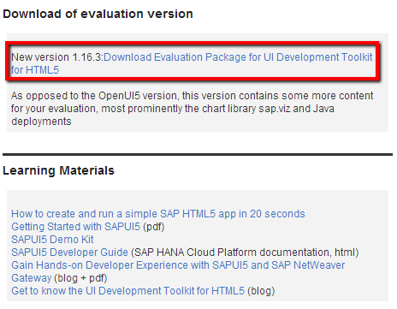

* Adobe Phonegap Build (optional)

[*https://build.phonegap.com/plans/free-adobeid*](https://build.phonegap.com/plans/free-adobeid)

If you don’t have the environment for compiling Android or iOS, you can use this cloud service to build your PhoneGap hybrid application. But personally, I suggest that you have all the tools installed on your computer, although it takes times to download and configure them in the beginning, it will save you a lot of time when debugging. However, if you want to have an iOS app, but you don’t have a Mac OS, Build will be necessary.

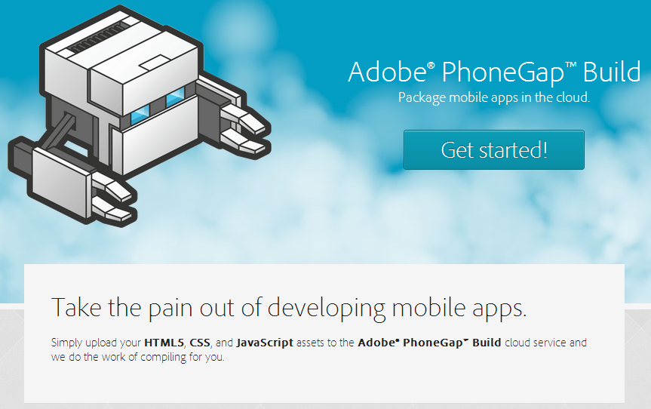

* SAP NetWeaver Gateway

If you want to build an application which consumes NetWeaver Gateway OData service, you need to have an account of your NetWeaver Gateway in order to access your OData service. For example, in our application, we used a NWGW OData service:

[*http://frparssm71.corp.capgemini.com:8000/sap/opu/odata/sap/Z_READ_VTTK_SRV*](http://frparssm71.corp.capgemini.com:8000/sap/opu/odata/sap/Z_READ_VTTK_SRV)

Authentication is required for accessing this service.

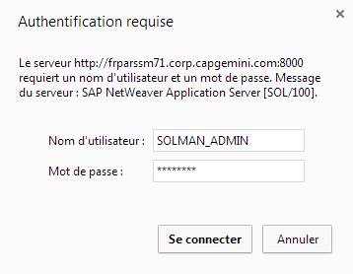

Now it’s time to install the tools and configure the environment! SAPUI5 is very ‘sensitive’, without the right version of the tools, you won’t make it works, so, get the most stable tools, not always the most recent ones. For example, you need an Eclipse JEE Juno, not Kepler. Kepler is cool, but SAPUI5 prefers Juno for the moment. ☺

I’ve downloaded and put all the tools (for Windows) in my Exchange, you can just copy them to your own computer. You can also download the tools via the link provided.

About SAPUI5

* [JDK (7)](http://www.oracle.com/technetwork/java/javase/downloads/jdk7-downloads-1880260.html)

*JDK is the Java package for developers, which includes a complete Java Runtime plus tools for developing, debugging, and monitoring Java applications. Java is necessary for compiling SAPUI5 project, if you were a web/javascript developer, you need to change your way of thinking, SAPUI5 is not like jQuery, you can’t just add the javascript sources code to your project and run the html file on the browser, you need a java runtime to make it works. Yes, it’s really painful for the normal web developer, like me!*

*After the installation of JDK, you need to set up a new environment variable JAVA_HOME.*

*Right click Computer => Property => Advance System Parameter => Environment Variable*

*Set the value of JAVA_HOME to the path of your JDK, then add %JAVA_HOME%; to path in your system variables.*

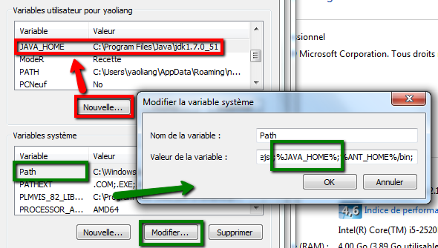

* [Eclipse JEE (Juno)](https://www.eclipse.org/downloads/packages/eclipse-ide-java-ee-developers/junosr2)

*Just unzip eclipse-jee-juno-SR2-win32-x86_64.zip into the location of your choice.*

* [Apache Tomcat (7)](http://tomcat.apache.org/download-70.cgi)

*See the tutorials for installing Tomcat 7 and using it in Eclipse*

[*http://www.coreservlets.com/Apache-Tomcat-Tutorial/tomcat-7-with-eclipse.html*](http://www.coreservlets.com/Apache-Tomcat-Tutorial/tomcat-7-with-eclipse.html)

[*https://sapui5.netweaver.ondemand.com/sdk/docs/guide/DetailsTomcat.html*](https://sapui5.netweaver.ondemand.com/sdk/docs/guide/DetailsTomcat.html)

* [UI Development Toolkit for HTLM5](http://scn.sap.com/community/developer-center/front-end)

*To install SAPUI5 Tools in Eclipse, proceed as follows:*

1. *In Eclipse, choose in the menu bar* ***Help > Install New Software***
2. *In the Install dialog, enter the following update site URL in the* ***Work with*** *entry field:* ***https://tools.hana.ondemand.com/juno***
3. *Press* ***Enter*** *to display the available features.*
4. *Select*

*Macintosh HD:Users:Leon1013:Desktop:Screen Shot 2014-04-21 at 7.22.10 PM.png*

1. *On the next wizard page, you get an overview of the features to be installed. Choose* ***Next****.*
2. *Confirm the* ***license agreements*** *and choose* ***Finish*** *to start the installation.*

*You can also find the UI Development Toolkit for HTML5 in my tools package, unzip it, there’s a sapui5-mobile-static.zip inside, unzip it, copy the folder ‘resource’ to the ‘www’ folder of the PhoneGap project you created, you’ll need it later for the deployment.*

* [Appbuilder (optional)](https://tools.hana.ondemand.com/#sapui5)

*A tool for rapid prototyping of SAPUI5 application, see here for more information:*

[*https://tools.hana.ondemand.com/#sapui5*](https://tools.hana.ondemand.com/#sapui5)

[*http://help.sap.com/appbuilder/*](http://help.sap.com/appbuilder/)

About PhoneGap, Android

* [Apache Ant](http://ant.apache.org/bindownload.cgi)

*You will need Ant to build Android application, see here for installing, similar to JDK.*

[*http://ant.apache.org/manual/index.html*](http://ant.apache.org/manual/index.html)

* [Android SDK](http://developer.android.com/sdk/index.html)

*Android SDK is required for compiling native & hybrid Android application, see here for instruction:* [*http://developer.android.com/sdk/index.html#download*](http://developer.android.com/sdk/index.html#download)

* [Nodejs](http://nodejs.org)

*Nodejs is a prerequisite for PhoneGap and Appbuilder.*

* [PhoneGap (Cordova)](http://phonegap.com/install/)

*Once you have nodejs installed, you can use this command to install PhoneGap:*

*npm install -g phonegap*

*After phonegap been installed, you can see here for how to create a PhoneGap project on its Command Line Interface:* [*http://docs.phonegap.com/en/edge/guide_cli_index.md.html*](http://docs.phonegap.com/en/edge/guide_cli_index.md.html)

*Don’t be confused between phonegap and cordova,they are the same thing (almost), just use one of them, don’t mix them up! If you use phonegap, use it from the beginning to the end!*

Git (Version control)

You need a version control tool, like Git! It will help you keep the trace of your development, so that you will know when, where you did a modification, and you won’t lose the most recent code. I didn’t use version control tool at the beginning, I managed the sources code manually, but finally, I got too much code, and sometime I didn’t know which one is the right, most recent one, this made me crazy, then I realized that I should use Git. This also helps if you use PhoneGap Build, you can retrieve your code directly from Github to build the hybrid apps on Cloud.

If you build your hybrid app locally with PhoneGap Command Line Interface, I suggest that you create two Git folders, one for the development of SAPUI5 in Eclipse, another for the deployment of hybrid application in PhoneGap. I’ll explain How To later in my case.

Mac OSX:

If you prefer using Mac OSX for development, the tutorial above also works, except that you need to configure JDK, Ant, Android SDK in another way, here you can find how to setup JAVA_HOME, ANT_HOME on Mac OSX:

[*http://www.mkyong.com/java/how-to-set-java_home-environment-variable-on-mac-os-x/*](http://www.mkyong.com/java/how-to-set-java_home-environment-variable-on-mac-os-x/)

[*https://ant.apache.org/manual/index.html*](https://ant.apache.org/manual/index.html)

I’ve also helped you downloaded all the tools, you can get them from my exchange. ☺

Device

Of course, you should some devices for testing your application, you’ll need to install USB driver for your Android device if you work on Windows, see here for more information:

[*http://developer.android.com/tools/extras/oem-usb.html*](http://developer.android.com/tools/extras/oem-usb.html)

I also put the USB driver of Nexus 7 in my exchange, if you also have one, just take it there!

## Chapter 2: Follow the tutorials and make a Hello World

Hope that you’ve installed all the tools successfully, it does take a lot of time and energy for just having a perfect environment, but it really deserves! If you meet some problems that I didn’t mentioned, you can email me or ask Google (especially SCN, Stackoverflow).

Now it’s time to make a Hello World and test your environment! I suggest that you take one or two days on reading through the SAPUI5 Developer Guide:

[*https://sapui5.netweaver.ondemand.com/sdk/#docs/guide/Documentation.html*](https://sapui5.netweaver.ondemand.com/sdk/#docs/guide/Documentation.html)

And see some examples here:

[*https://sapui5.netweaver.ondemand.com/sdk/#demoapps.html*](https://sapui5.netweaver.ondemand.com/sdk/#demoapps.html)

[*https://sapui5.netweaver.ondemand.com/sdk/test-resources/sap/m/demokit/explored*](https://sapui5.netweaver.ondemand.com/sdk/test-resources/sap/m/demokit/explored)

You can follow the tutorials/demoapps and create some simple SAPUI5 applications on Eclipse, run and test them, maybe you’ll meet some problems, for example, there might have nothing on Eclipse Web App Preview, you need to copy the url, then open a browser (Chrome, Firefox or IE 9+) and go to the address of your application, it should be works normally, if not, see here for troubleshooting:

[*https://sapui5.netweaver.ondemand.com/sdk/docs/guide/troubleshootingguide.html*](https://sapui5.netweaver.ondemand.com/sdk/docs/guide/troubleshootingguide.html)

And you should learn how to test your SAPUI5 application in Eclipse and debug on the browsers, here’s some important and very useful information that need to know:

* Browser support:

[*https://sapui5.netweaver.ondemand.com/sdk/docs/guide/BrowserSupport.html#SAPUI5forMobile*](https://sapui5.netweaver.ondemand.com/sdk/docs/guide/BrowserSupport.html#SAPUI5forMobile)

* Testing in Eclipse (important)

[*https://sapui5.netweaver.ondemand.com/sdk/docs/guide/TestingInEclipse.html*](https://sapui5.netweaver.ondemand.com/sdk/docs/guide/TestingInEclipse.html)

[*https://sapui5.netweaver.ondemand.com/sdk/docs/guide/TestingInEclipse.html#Backend*](https://sapui5.netweaver.ondemand.com/sdk/docs/guide/TestingInEclipse.html#Backend)

* Resource handling

[*https://sapui5.netweaver.ondemand.com/sdk/docs/guide/ResourceHandling.html*](https://sapui5.netweaver.ondemand.com/sdk/docs/guide/ResourceHandling.html)

* Debugging on Chrome

[*https://developers.google.com/chrome-developer-tools/docs/javascript-debugging*](https://developers.google.com/chrome-developer-tools/docs/javascript-debugging)

Read them patiently, do some experiments and enjoy debugging! ☺

## Chapter 3: Build a web application on Eclipse

## Chapter 4: Transform your web app to hybrid app with PhoneGap

## Chapter 5: Troubleshooting

* SAPUI5 development environment (eclipse, jdk, etc. required!!!)
  + JDK 7, Eclipse Juno, UI Dev tools in Eclipse, Tomcat, ant, appbuilder)
* Consume OData with SAPUI5 (understand OData structure)
* SAPUI5 app structure (MVC)
* Communicate between View and Controller
* Cross Origin problem
  + No 'Access-Control-Allow-Origin' header is present on the requested resource. Origin '[http://10.68.85.92:12525](http://10.68.85.92/)' is therefore not allowed access.
* Deploy with PhoneGap (Cl, build, appbuilder?)
  + https://sapui5.netweaver.ondemand.com/sdk/docs/guide/WebContainer.html
* Run code in Eclipse, local, remote, difference?
* Resources (SDK, SCN, Stackoverflow)
* Connection mobile phone: connectify, certificate
* Different between Web and Mobile version